
BENAZIR BHUTTO SHAHEED UNIVERSITTY LIYARI

Project Report

Title: Smart Traffic Light Control (Multi-Agent CSP vs Deep Q-Learning)
Members: Muhammad Usman, Shahab Ali, Mujahid Khan
Course: [Artificial Intelligence]
Instructor / Supervisor: [Mr. Anwar Ali]
Semester/Section: 6th (B)

Abstract
This project presents a comparative study of two artificial intelligence-based approaches to adaptive traffic signal control — Multi-Agent Constraint Satisfaction Problem (CSP) and Deep Q-Learning (DQN).
The system processes real or synthetic traffic datasets, performs data cleaning and feature engineering, scales numeric features, and divides data into 80/20 training and testing sets.
The CSP model provides a rule-based baseline solution that minimizes congestion through coordinated signal adjustments, while the DQN agent learns adaptive control policies through reinforcement learning.
Results demonstrate that DQN outperforms CSP in terms of adaptability and congestion reduction, with visual evidence showing improved performance across test scenarios.

Table of Contents
1 | Introduction
2 | Problem Statement
3 | Objectives
4 | Dataset & Preprocessing
5 | Methodology  o Multi-Agent CSP  o Deep Q-Learning (DQN)
6 | System Design & Implementation
7 | Experiments and Results
8 | Discussion and Limitations
9 | Conclusion and Future Work
10 | References
11 | Appendix: How to run / Notebook path

1. Introduction
Traffic congestion at urban intersections leads to long delays, high fuel consumption, and increased emissions. Traditional fixed-time signals cannot adapt to changing traffic patterns.
This project aims to develop a data-driven traffic signal control system that compares the performance of two distinct AI models:
- Multi-Agent CSP, which uses rule-based optimization to coordinate intersections.
- Deep Q-Learning, which learns adaptive policies through continuous interaction with traffic data.
The comparison evaluates which technique provides better congestion management and signal timing efficiency.

2. Problem Statement
Design and implement an intelligent traffic signal control system that:
• Learns from historical traffic data.
• Produces adaptive signal timing decisions to minimize congestion and waiting time.
• Compares the effectiveness of Multi-Agent CSP and Deep Q-Learning under identical conditions.
Performance is evaluated through congestion cost metrics, representing average waiting time and queue length across intersections.

3. Objectives
• Clean and preprocess traffic datasets (AADT and signal data).
• Normalize and transform numerical features using z-score scaling.
• Split data into 80/20 training and testing sets.
• Implement Multi-Agent CSP for rule-based optimization of signals.
• Implement Deep Q-Learning for adaptive signal control using reinforcement learning.
• Visualize model convergence and compare both approaches using congestion reduction metrics.

4. Dataset & Preprocessing
Files: The notebook loads multiple CSV datasets (AADT and signal data) for model training and testing.

Steps:
- Load CSVs: Import files using pandas and review basic statistics.
- Cleaning:
• Handle missing values using SimpleImputer (mean/median).
• Drop redundant or irrelevant columns.
• Encode categorical features if present.
- Feature Construction:
• Merge numeric features from both datasets into a unified DataFrame.
• Derive a target variable representing congestion (based on volume, flow rate, and waiting time).
- Scaling and Splitting:
• Apply StandardScaler for normalization.
• Perform an 80/20 split using train_test_split for consistent evaluation.
These steps ensure uniform data preparation for both CSP and DQN models.

5. Methodology

5.1 Multi-Agent CSP
• Each intersection acts as an independent agent with multiple signal phase options.
• Local and neighbor costs are defined to represent congestion and coordination penalties.
• A local search or greedy algorithm minimizes the total cost across intersections.
• The final configuration (ma_solution) serves as the baseline against which DQN performance is compared.

5.2 Deep Q-Learning (DQN)
• State: Vector representing real-time traffic features (flow rate, density, queue length).
• Action: Selection of the next signal phase or green time duration.
• Reward: Negative congestion cost; lower congestion yields higher reward.
• Neural Network: A PyTorch-based model mapping states to Q-values (expected rewards).
• Training Loop:
o Experience replay memory for stability.
o Epsilon-greedy exploration for balance between learning and exploitation.
o Mean Squared Error (MSE) loss for Q-value updates.
o Optimizer: Adam or RMSprop.
The DQN model learns optimal signal timing policies through repeated episodes, improving traffic throughput dynamically.

6. System Design & Implementation
Libraries Used:
NumPy, Pandas, Matplotlib, Scikit-learn, PyTorch, and standard Python libraries (random, os, math).
Implementation Workflow:
- Dataset loading and cleaning.
- Feature extraction and target derivation.
- Scaling and train/test split.
- Multi-Agent CSP implementation for baseline configuration.
- DQN training loop and reward evaluation.
- Model testing and visualization.
Visual Outputs:
• CSP convergence plot (total cost vs iteration).
• DQN reward curve (episodes vs average reward).
• Comparative bar/line plots showing CSP vs DQN performance.

7. Experiments and Results
Experiments were conducted using the prepared datasets and identical train/test splits for both models.
CSP Results:
• Converged quickly to a stable configuration.
• Produced consistent but static results across iterations.
DQN Results:
• Showed progressive improvement in average rewards.
• Demonstrated superior adaptability to dynamic traffic variations.
Comparison Summary:
• DQN achieved lower congestion scores on test data.
• Visualization plots confirmed CSP’s early stability and DQN’s long-term improvement.
• DQN outperformed CSP in adaptability, generalization, and reduction of overall congestion cost.
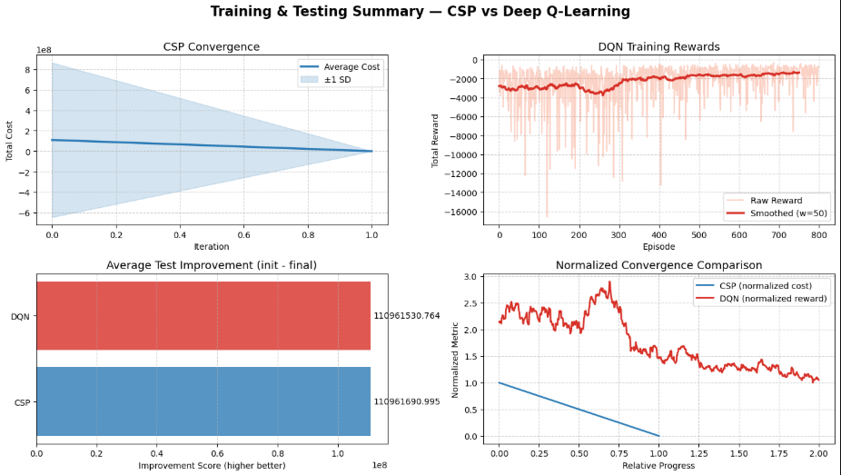

8. Discussion and Limitations
Strengths:
• Direct comparison reveals practical differences in algorithm behavior.
• Data preprocessing ensures consistent evaluation conditions.
• DQN’s reinforcement learning capability enables flexible policy generation.
Limitations:
• Lack of a high-fidelity traffic simulator limits real-world generalization.
• DQN training is computationally expensive.
• CSP scalability decreases with a higher number of intersections.
Reproducibility Notes:
• Random seeds set for numpy, torch, and random to ensure consistency.
• Saved trained models and normalization scalers for later inference.

9. Conclusion and Future Work
This project concludes that Deep Q-Learning (DQN) performs better than Multi-Agent CSP for adaptive traffic control.
While CSP offers structured and quick baseline optimization, DQN provides flexible, data-driven adaptability for varying traffic conditions.
Future Work:
• Integrate real-time sensor data from smart intersections.
• Implement multi-agent reinforcement learning (e.g., MADDPG, QMIX).
• Simulate large-scale scenarios using SUMO.
• Optimize training parameters for faster convergence.

10. References
• Sutton, R. S., & Barto, A. G. (2018). Reinforcement Learning: An Introduction. MIT Press.
• Russell, S., & Norvig, P. (2021). Artificial Intelligence: A Modern Approach (4th ed.). Pearson.
• Maryland Department of Transportation (MDOT). Annual Average Daily Traffic Data.
• Smart Traffic Signal Control Systems, IEEE Transactions on Intelligent Transportation Systems, 2023.

11. Appendix — How to Run / Notebook Path
Notebook Path (Uploaded): /Path/to/Smart_Traffic_Light_Control.ipynb
To Run Locally:
- Install dependencies:
pip install numpy pandas matplotlib scikit-learn torch notebook
- Open the notebook:
jupyter notebook /path/to/ Smart_Traffic_Light_Control.ipynb
- Run all cells from top to bottom.
- Ensure CSV data files are in the same directory.
Notebook Sections to Check:
• Data loading and preprocessing.
• Feature scaling and normalization.
• CSP baseline computation.
• DQN training parameters (episodes, batch size, learning rate).

